Aim of the project

To deploy a Telegram bot app to Azure container or a virtual machine locally, providing a highly reliable and scalable environment with robust security features and flexible pricing, while ensuring the app runs smoothly and efficiently, and providing an optimal user experience. This will be achieved by following best practices for deployment, testing, monitoring, and automation, and exploring areas for future work to further enhance the app's capabilities.

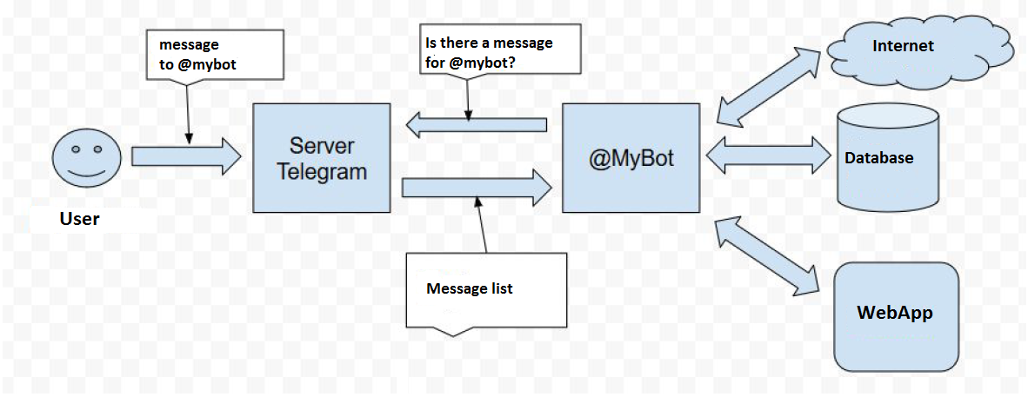

Comparison of the two methods

Deploying to Azure Container:  
Pros:  
- Highly scalable and reliable environment provided by Azure  
- Robust security features to protect the application and its data from cyber threats  
- Flexible and cost-effective pricing model  
- Easy to automate deployment processes using Azure DevOps  
- Built-in monitoring tools like Azure Monitor  
  
Cons:  
- Requires knowledge of Azure and its services  
- May require additional configuration and setup time  
- Dependency on internet connectivity  
  
Essential files:  
- Configuration files  
- Environment variables  
- Requirements file  
- Docker files  
- YAML files  
  
Setting up a Virtual Machine Locally:  
Pros:  
- Complete control over the environment and resources  
- No dependency on internet connectivity  
- No additional cost for hosting  
  
Cons:  
- Requires hardware resources to host the virtual machine  
- No built-in monitoring or security features  
- Limited scalability compared to Azure  
  
Essential files:  
- Programming code  
- Configuration files  
- Environment variables  
- Requirements file  
- Database setup and configuration files  
  
In summary, deploying the Telegram bot app to Azure container provides a highly scalable and reliable environment with robust security features and flexible pricing. It also allows for easy automation of deployment processes and built-in monitoring tools. However, it requires knowledge of Azure and its services and may require additional configuration and setup time. Setting up a virtual machine locally provides complete control over the environment and resources, but lacks built-in monitoring or security features and has limited scalability compared to Azure. Both methods require essential files such as configuration files, environment variables, and requirements files, but setting up a virtual machine locally also requires the setup and configuration of a database.

Detailed Elabroation on the Depolment

on Cloud Platform

Introduction:

After the comparison and some preliminary test on both platforms, decided to deploy the APP on Azure platform.

Deploying a Telegram bot app to Azure container offers several benefits, including a highly scalable and reliable environment for handling large amounts of traffic. Azure also provides robust security features to protect the application and its data from cyber threats, as well as a flexible and cost-effective pricing model that allows businesses to pay only for what they use. Optimizing costs while maintaining application performance is crucial for cloud platform engineers, and implementing security measures is necessary to ensure the safety of the application and its users.

**Workflow and Cooperation of the Whole System**

**Overview**

The flow of deploying a Telegram bot app to Azure involves creating a Docker container for the app, storing the container on Docker Hub, defining the Azure Container Instance using YAML files, and setting up the necessary configurations and environment variables. Programming code and other necessary files are stored on GitHub. The app is then deployed to Azure Container Instance, where it is hosted and can be accessed by users. Best practices for deployment, testing, and monitoring are followed to ensure the app runs smoothly and efficiently. The flow of data involves user requests being sent to the Azure Container Instance, where the app processes them and retrieves data from the MangoDB database. Results are then presented back to the user through the user interface.

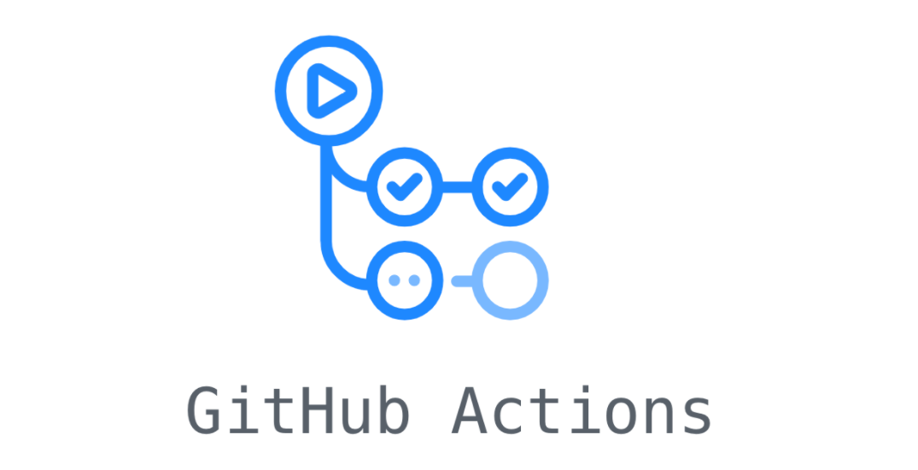

**Github/workflow/**

**main.yml**

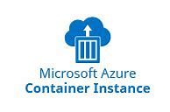

**Environment Variables**

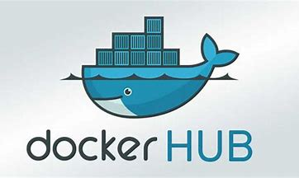

 

**APPS/API with Token**





**GitHub repo**

**(Dockerfile)**

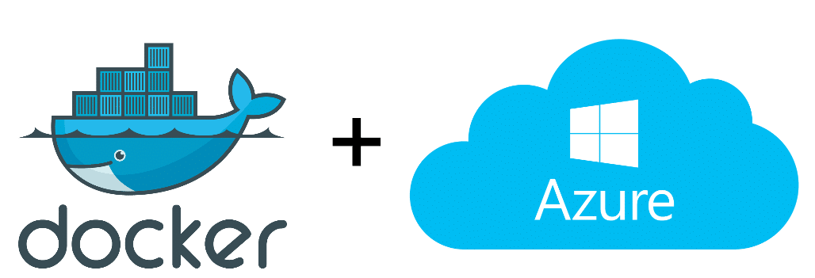**Systems and Steps:**

**Docker Hub and Azure**

* The flow of using Docker and ACI together typically involves the following steps:
* The application was packaged into a Docker container using a Dockerfile.
* The Docker image was then pushed to an Azure Container
* The container image is then deployed to an Azure Container Instance using the Azure
* ACI takes care of provisioning the resources needed to run the container and starts it up

*Create docker container deploy to Azure through Webhooks*

*depolyment process 1 depolyment process 2*

*Container running on Azure*

**Azure and GitHub**

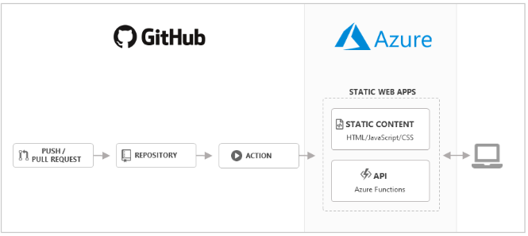 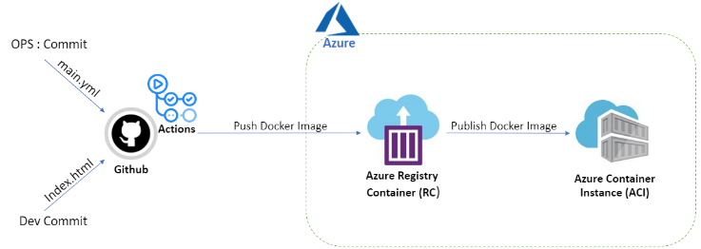

* GitHub that allowed us to automate our software development workflows.
* With the Azure Web Deploy action, we could automate our workflow to deploy custom containers to App Service using GitHub Actions.
* A workflow was defined by a YAML file in the /.github/workflows/ path in our repository. The file had three sections: Authentication, Build, and Deploy. It retrieved credentials, built the container image, and deployed it.
* Upon pushing code changes to a GitHub repository, a GitHub Actions workflow is initiated. This workflow constructs a Docker image from the source code and subsequently transfers it to an Azure Container Registry. The image can then be deployed to an Azure Web App for Containers.

*GitHub actions setup succussed GitHub environment variables setting for Azure*

**Connection between GitHub and Docker Hub**

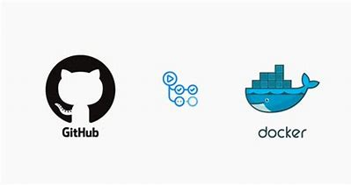

* Actions in Github are configured to monitor GitHub repositories and automatically trigger builds and pushes to Docker Hub.
* Once the new Docker image is pushed to Docker Hub, it can be pulled and deployed to production environments.
* This process ensures that the most up-to-date version of the code is always deployed, and that any changes are automatically reflected in the Docker image.
* Additionally, Docker Hub provides features such as webhooks and automated builds, which can be used to trigger builds and updates whenever changes are made to the GitHub repository.

*Connection between GitHub and Docker Hub*

**

**Part II: Essential files for depolyment**

Besides the Telegram Bot APP, the following files are crucial to the deployment process:  
  
2.1 Configuration Files:  
Configuration files are used to specify the settings and parameters of the application. In this case, the configuration file will contain information about the Telegram bot app and the database connection.  
  
2.2 Environment Variables:  
Environment variables are used to define the runtime environment of the application. They are used to store configuration values and other sensitive information.  
  
2.3 Requirements:  
The requirements file lists all the dependencies required for the app to run correctly. It includes libraries and modules that the application needs to function correctly.  
  
2.4 Docker Files:  
Docker files are used to create a Docker container for the Telegram bot app. The Docker container is used to deploy the app on Azure.  
  
2.5 YAML Files:  
YAML files are used to define the Azure pipeline. They specify the build and deployment processes for the application.  
  
  
  
3. Best Practices for Deployment:  
Deploying a Telegram bot app to Azure container requires following some best practices to ensure a successful deployment. As a cloud platform engineer, it's important to test the application thoroughly before deployment to identify and fix any issues. This includes testing the application's functionality and performance. In addition, it's crucial to monitor the application's performance after deployment to ensure it's running smoothly. This can be accomplished by implementing monitoring tools like Azure Monitor. It's also important to implement automated deployment processes using tools like Azure DevOps. This can help streamline the deployment process and reduce the risk of errors. Finally, as a cloud platform engineer, it's important to keep the application and its dependencies up to date to avoid security vulnerabilities. This includes regularly updating the application's software and libraries to the latest versions. By following these best practices, a cloud platform engineer can ensure a successful deployment of a Telegram bot app to Azure container.  
  
**5. Flow of Data**:  
The flow of data in the application is as follows:  
  
5.1 User Interface:  
The user interacts with the Telegram bot app through the user interface.

5.2 Cloud:  
The Telegram bot app is hosted on Azure. The user's requests are sent to the Azure container, where the app processes them.  
  
5.3 Database:  
The data is stored in MangoDB, which is connected to the Telegram bot app using the configuration file.  
  
5.4 Final Presentation to User:  
The results of the user's requests are presented back to the user through the user interface.

6. Future Work:  
In the future, there are several areas that could be explored to improve the Telegram bot app deployed to Azure. For example, the application could be further optimized for performance by implementing caching mechanisms or load balancing. Additionally, implementing a disaster recovery plan is crucial to ensure the application can quickly recover from any unexpected downtime or failure. This could be accomplished by implementing a backup and recovery strategy using Azure's built-in tools or third-party solutions. In addition, incorporating machine learning capabilities into the application could provide more personalized and accurate results for users. Finally, implementing a continuous integration and delivery (CI/CD) pipeline can help streamline the development and deployment process, allowing for faster and more frequent releases of the application. By exploring these areas, a cloud platform engineer can further enhance the Telegram bot app and provide a better experience for its users.

*Readiness for scale out*

7. Conclusion:  
In conclusion, deploying a Telegram bot app to Azure container is a powerful solution for businesses looking to take advantage of the cloud platform. By following best practices for deployment and keeping the application up to date, a cloud platform engineer can ensure a successful deployment and optimal performance of the application. The flow of data from the user interface to the cloud and database, and back to the user, is crucial to the application's functionality. And by exploring areas for future work, a cloud platform engineer can further enhance the application's capabilities and provide a better experience for its users.